Interrogative Sentences

✅ Definition:
# Source: Chatgpt (GPT-4-turbo) at [7/28/2025]
An interrogative sentence is a sentence that asks a question.
Its main function is to request information, confirmation, or clarification.

🧩 Key Features of Interrogative Sentences:
# Source: Chatgpt (GPT-4-turbo) at [7/28/2025]
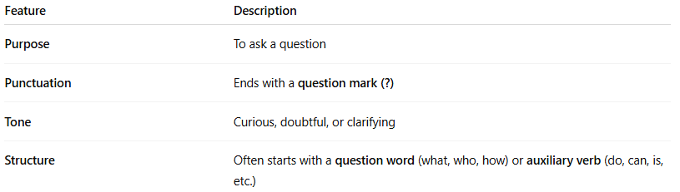
Feature | Description
Purpose | To ask a question
Punctuation | Ends with a question mark (?)
Tone | Curious, doubtful, or clarifying
Structure | Often starts with a question word (what, who, how) or auxiliary verb (do, can, is, etc.)

✏️ Examples of Interrogative Sentences:
# Source: Chatgpt (GPT-4-turbo) at [7/28/2025]
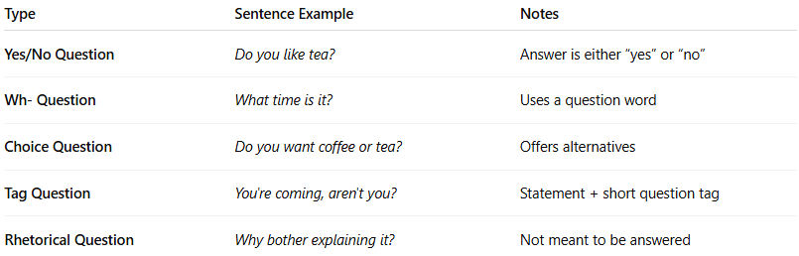
Type | Sentence Example | Notes
Yes/No Question | Do you like tea? | Answer is either “yes” or “no”
Wh- Question | What time is it? | Uses a question word
Choice Question | Do you want coffee or tea? | Offers alternatives
Tag Question | You're coming, aren't you? | Statement + short question tag
Rhetorical Question | Why bother explaining it? | Not meant to be answered

🔧 Basic Structures:
# Source: Chatgpt (GPT-4-turbo) at [7/28/2025]
- Yes/No Question:
Auxiliary + Subject + Verb + ...?
→ Did you finish your homework?
- Wh- Question:
Wh-word + Auxiliary + Subject + Verb + ...?
→ Where does she live?
- Tag Question:
Statement + , + tag?
→ It’s cold today, isn’t it?

⚠️ Note:
# Source: Chatgpt (GPT-4-turbo) at [7/28/2025]
- Interrogative sentences must end with a question mark.
- Sometimes, rhetorical questions don't require an actual answer.

🔍 Interrogative Sentence vs. Others
# Source: Chatgpt (GPT-4-turbo) at [7/28/2025]
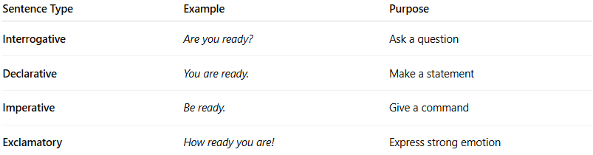
Sentence Type | Example | Purpose
Interrogative | Are you ready? | Ask a question
Declarative | You are ready. | Make a statement
Imperative | Be ready. | Give a command
Exclamatory | How ready you are! | Express strong emotion

🧠 Summary:
# Source: Chatgpt (GPT-4-turbo) at [7/28/2025]
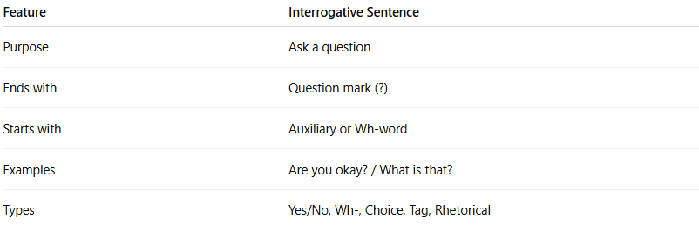
Feature | Interrogative Sentence
Purpose | Ask a question
Ends with | Question mark (?)
Starts with | Auxiliary or Wh-word
Examples | Are you okay? / What is that?
Types | Yes/No, Wh-, Choice, Tag, Rhetorical

